1. Happy Scenario - 6d894a91-69f5-4ef2-b359-4528e74472d2

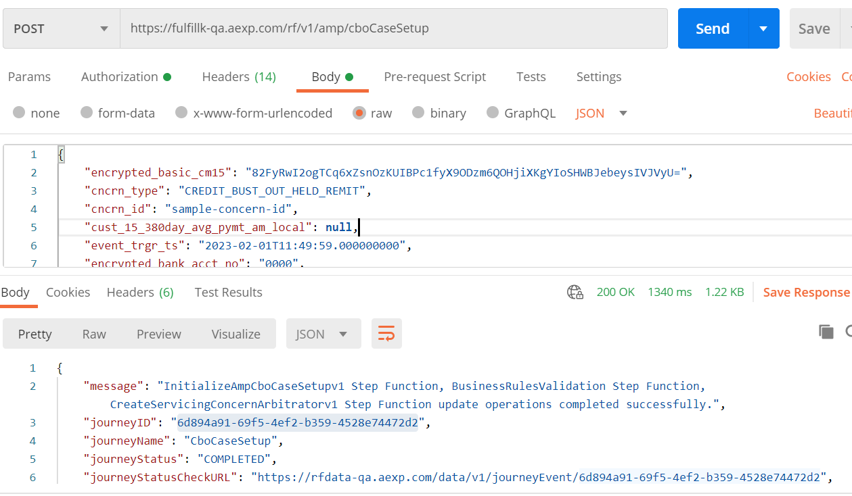

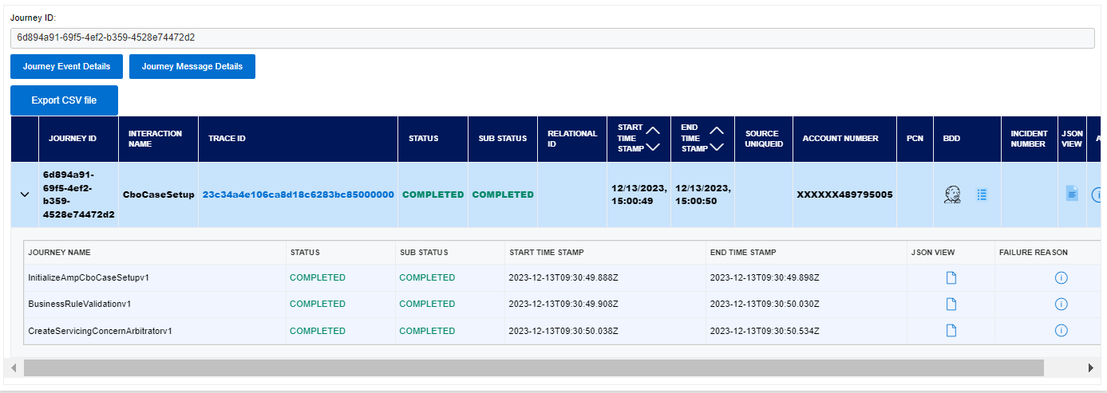

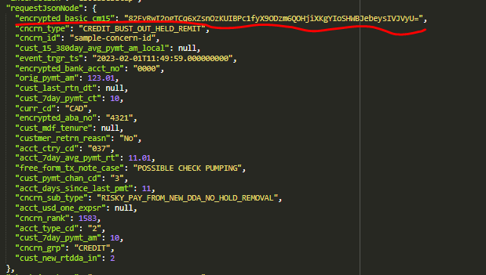

Verify the CreateServicingConcernArbitratorv1 step function – accountIdentifier.

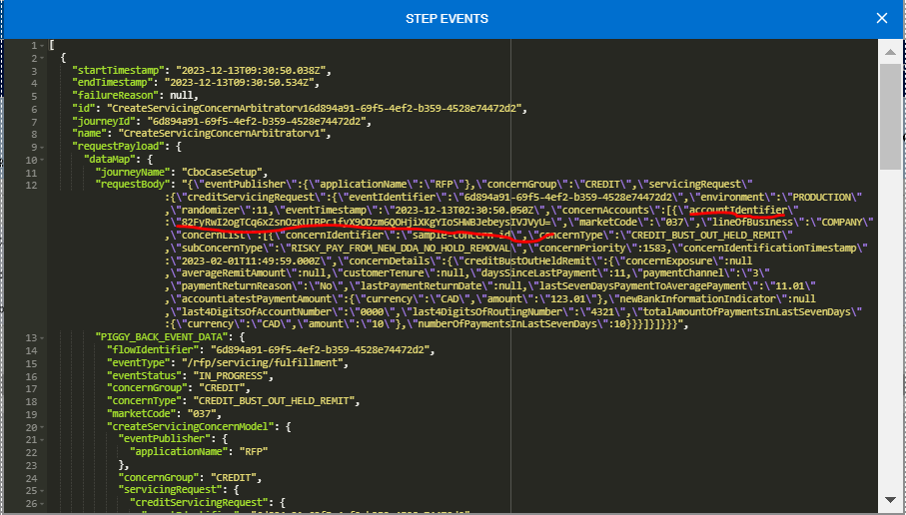

1. Missing - encrypted_basic_cm15 is null -> 46461ed3-88ed-4251-b95f-49e7e1335e4d

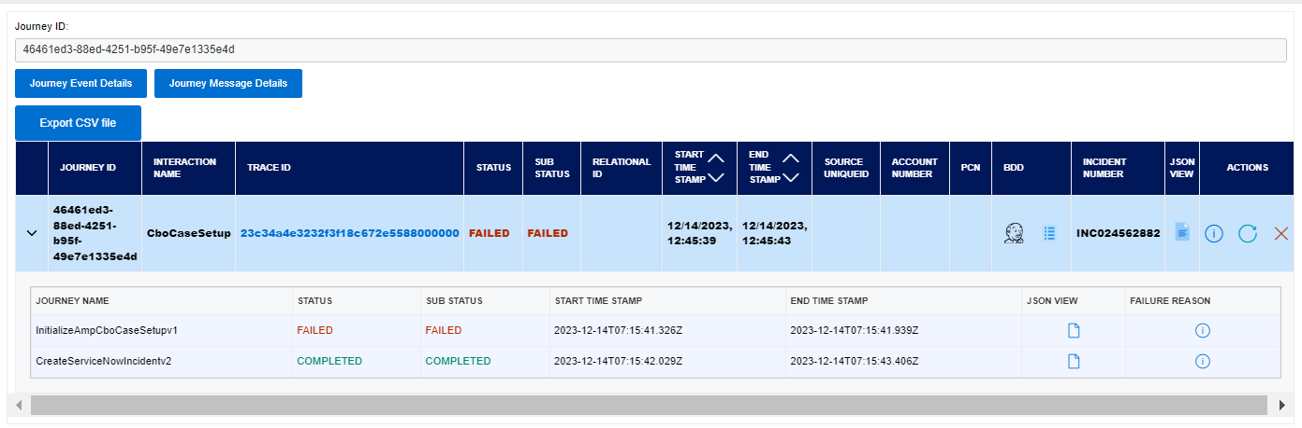

Verify the exception – “Must be at least 16 bytes in length”.

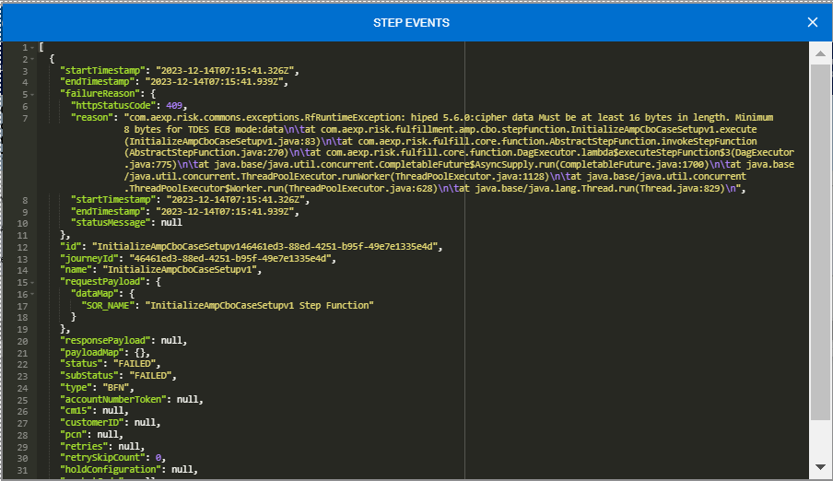

1. Empty- encrypted_basic_cm15 is empty-> 82e980d1-2993-4071-8a59-41fc0bea4e67

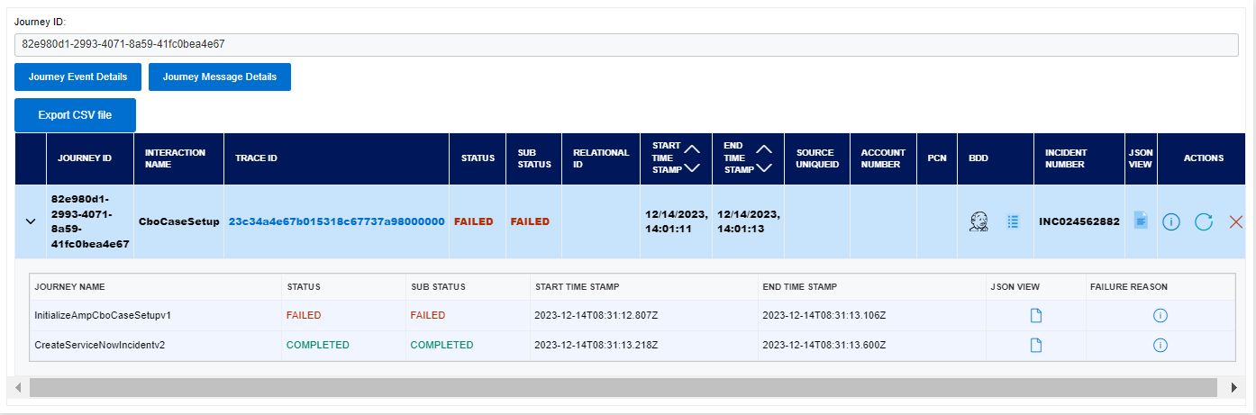

Verify the exception – “Null data or invalid data for encrypt/decrypt operation”.

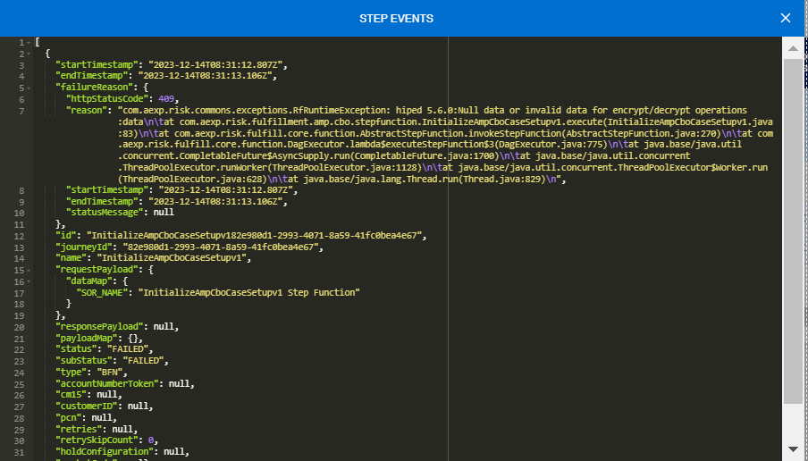

1. Too Long- encrypted_basic_cm15 is Too Long-> 414a68b3-27db-43a4-bf90-1f4e6c5deba7

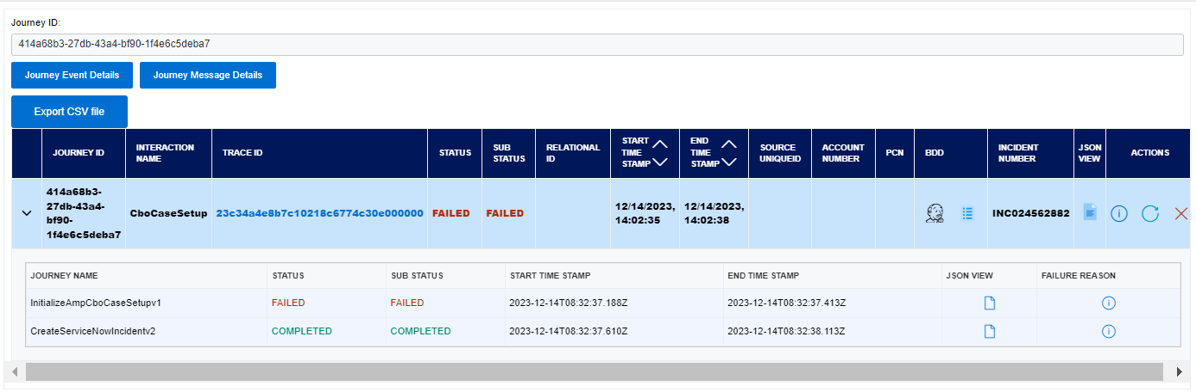

Verify the exception – “unable to decode base64 string: invalid characters encountered in base64”.

